BALLYMAHON MUNICIPAL DISTRICT

Corporate Affairs,
Aras an Chontae,
LONGFOIRT.

15th March 2018.

To: Each Member of Ballymahon Municipal District.

Dear Member,

You are requested to attend Meeting of Ballymahon Municipal District to be held in Ballymahon Community Library on Thursday, 22nd March 2018 at 4.00 p.m. to transact business, as set out on the Agenda hereunder.

Yours sincerely,
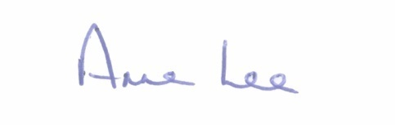

_______________
Anne Lee,
Meetings Administrator.

AGENDA

Prayer before meeting.

1. Confirmation of Minutes of the following Meetings of Ballymahon Municipal District -

- Committee Meeting held on the 25th January 2018.
- January Meeting held on the 25th January 2018.
- Committee Meeting held on the 12th March 2018.
- Special Meeting held on the 12th March 2018.
- copies enclosed.

2. Matters arising from Minutes.

3. Management Report - enclosed.

4. Presentation by Stonepark Tidy Towns Committee.

5. Consideration of applications for funding under the 2018 Community Grant Support Scheme - report enclosed.

6. Notices of Motions submitted by Councillors, as listed hereunder

Councillor Gerard Farrell.

“I call on Longford County Council Roads Department to carry out widening and signage works on the road leading to Fermoyle School from Morans Cross to the school. There was a serious road crash there at peak school time involving young children and something needs to be done soon.”

“That Longford County Council’s Environment Section provides bins at Barley Harbour, Newtowncashel.”

“That Longford County Council resurfaces the Main Street in Lanesboro, as it is in bad repair.”

Councillor Mark Casey.

“Can I have an update on when flood relief work will be carried out at Tommy Farrells house in Gourteengar and at Flanagan’s house in Newtowncashel.
Both of these issues are ongoing and have previously been approved
motions.”

“Can I have an update on my historical motion on the fixing the fence at the
Carpark at Curry Church.”

Councillor Mick Cahill.

That Longford County Council facilitates the setting up of a "Town Team" in Edgeworthstown in the interests of economic and sustainable development of the town"

Councillor Paul Ross.

“That Longford County Council & Ballymahon Municipal District establish a Town Team in Edgeworthstown.”

“That Longford County Council applies for a Low Cost Safety Scheme on the L-1095-0 at Ballinareaghan, Ardagh at the right turn for Barney, Ardagh, due to a number of incidents at this junction and in the interest of public safety.”

7. A.O.B.

